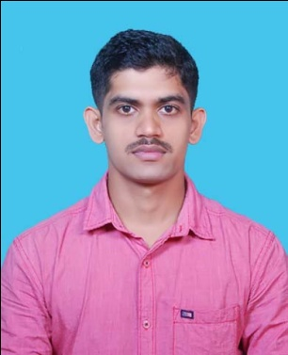
CURRICULAM VITAE

SHRIKANTH
S/o Derappa Moolya
Dasakodi house
Balthila Village and Post,
Bantwal Taluk, D. K
Karnataka -574253
Email:shrikanthsoori@gmail.com
Ph:9686048654, 9611308654

OBJECTIVES:

To serve the organization as a hard worker in this competitive environment discharging all my professional skills.

ACADEMIC QUALIFICATIONS:

EXAMINATION | SUBJECTS | BOARD/UNIVERSITY | YEAR | PERCENTAGE
M.Sc | Computer Science | Center for PG Studies and Research St.Philomena College Puttur. | 2014-2016 | 61.84%
B.Sc | Physics, Mathematics,  Computer Science | St.Philomena College puttur . | 2011-2014 | 63.88%
PUC | Physics, Chemistry, Mathematics, Statistics | Shri Ramakunjeshwara Pre University College Ramakunja. | 2009-2011 | 63%
SSLC |  | Govt.Junior college Puttur. | 2008-2009 | 65.92%

STRENGHTHS:

Disciplined, sincere and honest, hardworking, keen to learn and improve skills, regular and punctual, self-motivated Positive and practical.

TECHNICAL SKIILS:

Programming Languages | C, C++,C#,Java,HTML,VB,.Net
Database | Oracle
Operating Systems | Linux, Windows XP, Windows 7
Networking Skills | Networking Basics

PROJECT PROFILE:

Worked project on ”Resource Planner“ in M.Sc using PHP as a front end and MySql server 2008 as a back end.

PERSONAL DETAILS:

Date of birth : 03-06-1993

Father Name : Derappa Moolya

Mother Name : Nayana

Nationality : Indian

Marital status : Single

Gender : Male

Language known :

Written | English, Hindi, Kannada.
Spoken | Kannada, English, Tulu, Hindi

DECLARATION:
I hereby declare that all statements made in this application are true complete and correct to the best of my knowledge and beliefs

Date: Yours Faithfully
Place: Dasakodi (SHRIKANTH)

